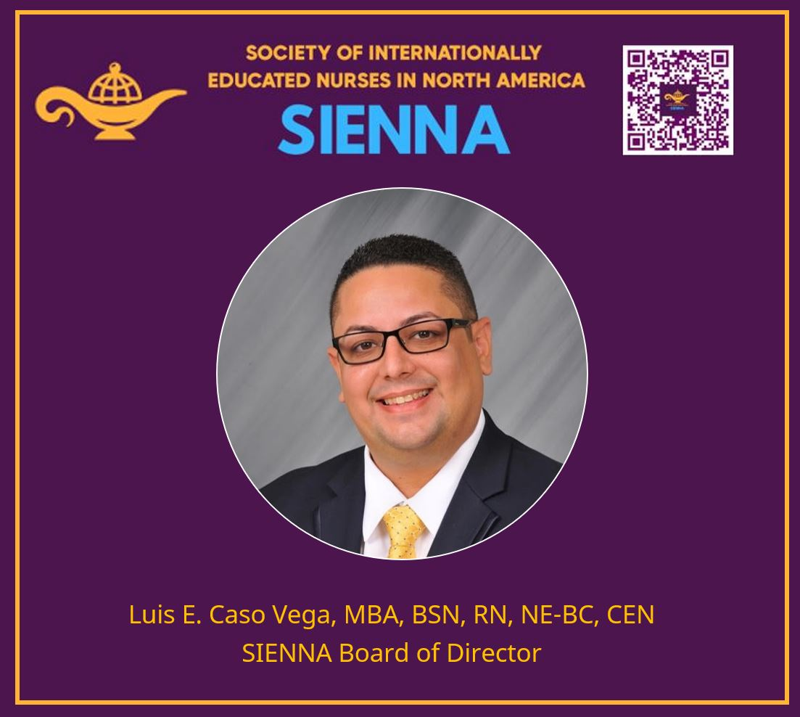

Luis (He/Him) is a highly skilled and compassionate registered nurse with 12 years of invaluable experience in emergency services and leadership roles. With a strong educational foundation, Luis holds a Bachelor of Science in Nursing (BSN) and a Master of Business Administration (MBA). Currently, he is pursuing a Doctor of Nursing Practice (DNP) degree at Nova Southeastern University further expanding his knowledge and expertise.
With a firm commitment to lifelong learning, he aims to enhance his understanding of healthcare and contribute to the field through academia. As he works towards this goal, Luis aspires to transition into the academic world, where he can educate and inspire future generations of nursing professionals. He is currently a Lecturer at NUC University teaching HEMA 1010-Healthcare Policies Planning and Management and HEMA 1020 - Legal and Ethical Issues in Health Services Administration.
Connect with Luis to learn more about his experiences, share insights, and explore potential collaborations in the healthcare and academic spheres.

